Somalia Hunger Story Outline

What is a Hunger Crisis?
The IPC classifies food insecurity across five phases of increasing severity. In Phase 1 (Minimal), households can meet their basic needs without resorting to unusual strategies. Phase 2 (Stressed) sees households managing adequate food consumption but struggling to cover non-food essentials, forcing some stress-coping behaviors. By Phase 3 (Crisis), households face actual food consumption gaps reflected in elevated acute malnutrition, or are barely meeting minimum food needs by depleting livelihood assets. Phase 4 (Emergency) is marked by large food consumption gaps, very high acute malnutrition, and excess mortality, with households liquidating assets just to survive. Phase 5 (Catastrophe/Famine) represents the most extreme end, where households face total food deprivation even after exhausting all coping mechanisms, with starvation, destitution, and critically high malnutrition and mortality. The corresponding response objectives escalate accordingly — from building resilience at Phase 1, to protecting livelihoods at Phases 2 and 3, to saving lives at Phase 4, and finally to preventing widespread death and total livelihood collapse at Phase 5.
IPC Classifies a Crisis as Phase 3 and above.
  - In the 30 countries that the IPC/CH analyzes, a group that contains the nations with the most dire hunger circumstances, currently 146.53 million people are in crisis of worse, Phase 3+ (IPC/CH Dashboard)
- (Reference to the data availability and collection section) What is most troubling is that it might not look like anything at all, at least at the beginning. The people that are most likely to be affected by these things are the people that are the hardest to reach and the people that might not be the most “visible”
- There are many things that could cause a hunger crisis
  - Structural Instability in the government can make it harder to provide aid
  - Price instability in food and fuel
  - Climate is a large factor as well. It exacerbates many of the other factors
    - More variable rainfall patterns mean a smaller harvest, forcing farmers to lean on volatile food prices
      - Maybe we can include a graph about the amount of rainfall or the year-over-year change in rainfall
    - Fewer resources, like arable land and fresh water, lead to increased hostility within a nation, leading to civil unrest and instability
      - Include figures about Somalia’s total number of displaces peoples
- All of these factors are present in Somalia, a nation that has continuously suffered from crisis after crisis.
What is the Current State of Somalia?
- Somalia has historically been one of the most undernourished nations in the world, by a wide margin. As of July 2026, Somalia has the 7th highest proportion of people in IPC Phase 3+ (Dashboard)
  - 31% of population, over 6 million people

  - 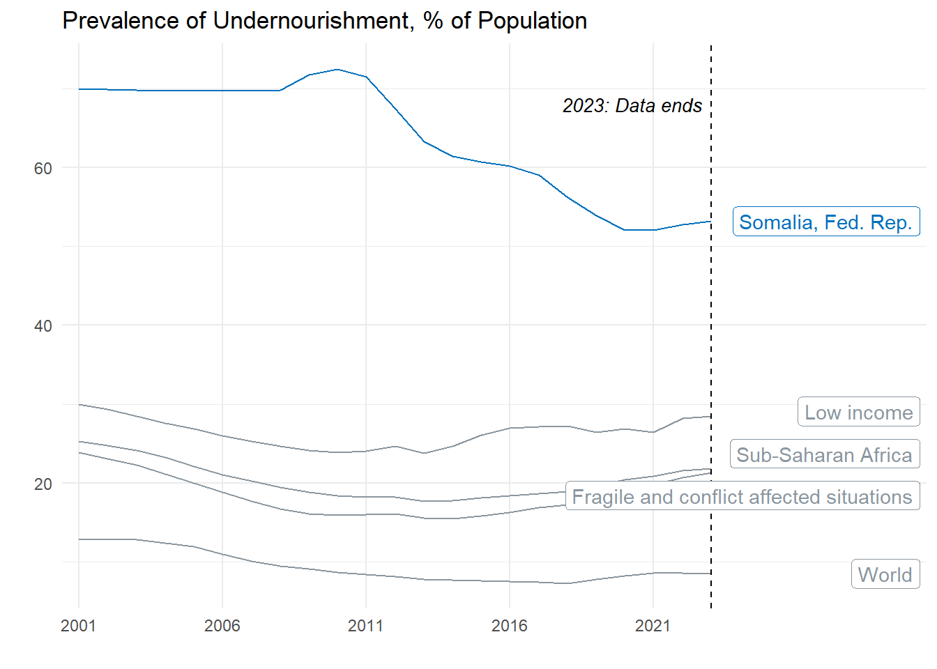
- In recent years, however, some indicators show that Somalia’s plight has improved. Looking at undernourishment, in 2010, 73% of the population was undernourished. This has improved to 53% in 2023.
- This was largely due to a coordinated effort from humanitarian groups to
- But if we look at more recent and granular data, we can see that Somalia is still struggling, in fact, food insecurity is currently on the rise. Since the beginning of 2020, when 10% of the population was in IPC Phase 3+, the percent of people in food insecure conditions has worsened. As of April, the proportion of people in IPC Phase 3+ has tripled 2020’s statistic. Now, over 30% of the population in Somalia is classified by the IPC as in a crisis or worse.
- 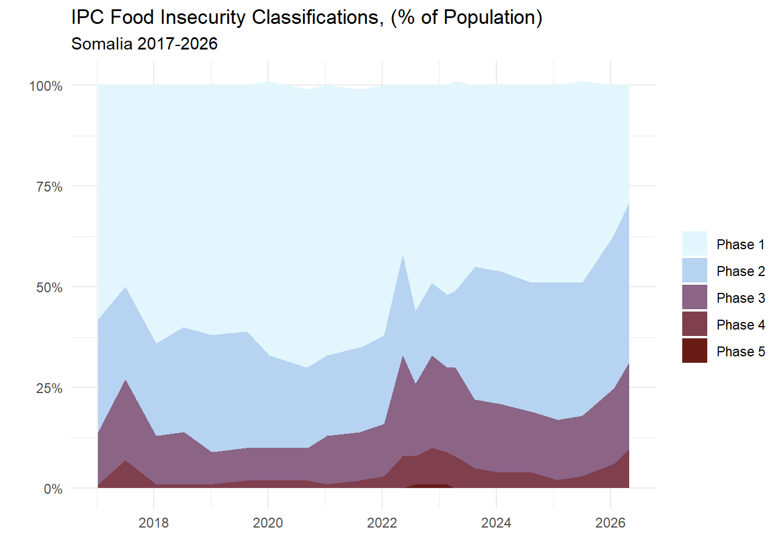
- This current crisis is driven by a few factors: Climate, decreasing humanitarian assistance, and 2026 Middle East Conflict
  - Climate:
    - Rainfall during the Gu season is below predicted levels, which has persisted in the ongoing drought. The was preceded by a failed 2025 Deyr season and especially harsh and dry Jilaal
      - El Nino forecasts signal increased flooding risk later in the year
    - Failed 2025 Deyr harvest has impacted the carry-over stock from previous seasons, along with increases in fuel prices and imported food costs, this has caused an increase in food prices in the country
  - Conflict:
    - Ongoing conflict in many parts of the country has disrupted agricultural production, markets, and access to humanitarian aid
  - Aid:
    - Humanitarian aid has be severely limited due to large funding cutbacks
      - WFP: “More than 500 health and nutrition facilities have been closed across the country due to lack of funding, with disease outbreaks not being controlled and mortality risks rising.”
      - WFP: “Total measles cases across Somalia have doubled during January to March 2026 compared to the first quarter of 2025, particularly impacting vulnerable and already acutely malnourished children.”
      - Somalia Humanitarian Needs and Response Plan 2026 is only 20.8% funded (OCHA FTS)
        - 577,000 people were reached from January to April against a target of 2.43 million (24% coverage)
- The scale of the current crisis is large:
  - Approximately 6 million (~31%) in IPC Phase 3+
    - 1.9 million in IPC Phase 4, nearly tripled in less than a year
    - Conditions are expected to deteriorate further between June and November 2026.
    - 1.88 million children aged 6-59 months are acutely malnourished
      - 493,000 Severe Acute Malnutrition
      - 1,385,000 Moderate Acute Malnutrition
  - Due to factors like drought (41%), conflict (23%), and flooding (36%), 304,000 people across Somalia were displaced internally between April and June 2026
  - Famine Risk has emerged for the first time since the 2022 crisis:
    - The Burhakaba district in the Bay region faces a famine threat
    - This is dependent on continued failure of seasonal rains, sharp food price increases, and insufficient humanitarian aid reaching affected populations.
  - The 2022 Crisis: Aftermath of the longest drought on record
    - Famine was averted through massively scaled up and sustained humanitarian interventions in the aftermath of the longest drought on record.
  - Sources: IPC April-June Report and WFP 2026
- This current crisis and the nature of this current crisis is not new for Somalia, these factors have been historical drivers for food crises in Somalia for the past 30 years:
  - Climate
    - Gaps between droughts are shrinking and the severity is increasing
    - 2022-23 drought was the worst in 40 years, five consecutive failed seasons. There have been three “worst droughts in decades” in the past 15 years (ConcernUSA 2022)
    - Drought then flood whiplash: the 2023 El Niño floods came immediately after drought
    - Poorer harvests increases food dependency:
      - Somalia now produces less than half the food it did before the collapse of the state in 1991. (IRC, 2023)
      - It is heavily dependent on food imports; over 90% of wheat historically from Russia and Ukraine, before the war. (IRC 2023)
      - 2026 Middle East conflict is doing the same; diesel and petrol prices are up 30–60% in southern regions, so supply chains are disrupted. (IPC May 2026)
  - Conflict
    - arable and grazing lands were commandeered by powerful insurgent groups in many different regions, the same regions where the hunger was the worst (Maxwell 2012)
    - Continued conflict disrupts agriculture, markets and humanitarian access (IPC May 2026)
    - The government collapse of 1991 decreased security, infrastructure and services
    - Basic services such as healthcare, education, agricultural extension and veterinary services were either privatized or provided through humanitarian services (Maxwell 2012).
  - All these factors lead to more and more internally displaced people, running from conflict, leaving land that is no longer arable, and in search of aid that is increasingly harder to find
    - Displacement sharply increases the fragility of a family, as it strips them of land, assets, livestock, and social strategies, it massively erodes historically established coping strategies.
    - At the time the 2010 drought hit, 1.46 million Somalis were already internally displaced, almost entirely due to conflict. Today 3.4 million people are internally displaced. (Maxwell 2012) (IPC May 2026)
    - (Can include a viz here: We can do a chart or a scroller adding annotations on events like conflicts or climate events)
- The “interwovenness” of these factors means that the detection of oncoming crises is very hard. Even when they are detected, the warnings must still be heeded and acted upon
  - One of the worst famines in the world (maybe) occurred in Somalia from 2010-2012
    - It took place only 6 months after a harvest that was well above the 5 year average (Maxwell 2012)
    - Nearly 260,000 died in this famine, half of them were children (UN News)
  - There had been early warning of a crisis in the Horn—and specific warnings about Somalia—for nearly 11 months prior to the declaration of famine, but these warnings weren’t heeded
- The problem was that the warnings weren’t believed
Fighting Hunger with National Preparedness Plans
- On January 1st, 2024, Somalia operationalized a “Preparedness Plan for Food and Nutrition Security Crises”
  - The plan sets clear triggers (like failed rains, major flooding, or malnutrition thresholds) for declaring an extraordinary food security crisis, and lays out a fast, coordinated response process among the Somali government, UN agencies, and humanitarian and development partners to mobilize funding and aid before a crisis becomes a famine.
  - Implementation of this plan is required in order to access Crisis Response Window funding from the IDA
- A part of the plan is the implementation of a structured informational pipeline that increases the credibility of data and warnings
  - Pipeline: Data gets collected > Country Risk Team (led by national bureau of stats + line ministries) recognizes risk > Programming team creates a response plan (organized by the nations’ ministry of planning or finance) > Senior Team approves and triggers the plan and an international round table is convened to bolster multinational awareness (Geneva Talk Slides)
  - Joint Monitoring Report is a part of this, at the beginning: To provide faster, more flexible, data driven approach to monitoring food security
  - Bi-monthly (I think every other month) snapshots of food and nutrition security risks using advanced statistical methods, machine learning, and artificial intelligence. (Geneva Talk)
  - On conflict, climate, economic shocks
  - We can use some version of the scroller on the JMR briefing site to show how it considers many different sources of data
- “Conventional food insecurity assessment methods typically involve extensive data collection, consensus-building processes, and expert evaluations.” (Yemen JMR Blog)
  - JMR: innovative data-driven methodology aimed at the early detection of food and nutrition security emergencies in Yemen.”
  - Granular, High-frequency data decreases the gap between the events occurring and people in power finding out about them. Governments gain a better sense of oncoming crises as they are happening, instead of after they have gotten out of control
  - A Risk Team, usually based in the country, takes the data from the JMR along with other data like IPC data to determine whether a warning should be passed up the pipeline
- Data can help uncloud the nature of the situation, giving reliable and believable information that officials can act upon.
- The biggest barrier to the efficient and effective execution of preparedness plan is the availability of data. To calibrate the models that reports like the JMR are based on, there needs to be sufficient up-to-date ground truth data. Even the most advanced AI models risk misrepresenting data and presenting inaccurate analysis. There has been some investigation on alternative sources of data, ex. Market price data from Telegram channels or crowdsourced market data, but the idea is that we can tie these data that are being used to more national statistics. (Meeting 31:08)
- This is already being applied to multiple other countries. There are preparedness plans in many countries, and they are currently holding workshops for the Risk Teams in those countries. The most recent one was Haiti, July 24th (Meeting 19:40) Currently 17 countries with JMR, 15 of which are govt led (Geneva Talk Slides)
Research on the cause of PoU decline from 2010-2023
- IAHE: Response to the Humanitarian Crisis in Somalia 2025
  - 2021-2023 Hunger Crisis
  - Humanitarian funding more than doubled that year to over US$2.3 billion in 2022
  - Est. 74,700 people, mainly children under five, died in 2022–2023 due to the drought
    - Death toll would have been higher if not for the massive scale up in humanitarian aid, averted reaching famine thresholds.
  - Early warning was good; funding was slow anyway. High-quality early warning data was used early to advocate for scale-up, but significant additional funding still took too long to materialize, though pooled funds and internal advance financing helped speed some of the response.
  - Data quality was a systemic weakness. Even basic figures like total population size or number of displaced people were disputed, and reach data didn't add up to a plausible picture at the inter-cluster level
- Reestablishment of a National Government
- OCHA Somalia Drought Situation Report No. 5 (23 April 2017)
  - Seed and cash vouchers (Gu planting season)
    - ~230,000 people, mainly in Somalia's southern breadbasket, in IPC Phase 4 (Emergency) are receiving seed vouchers for Gu planting plus cash vouchers for 3 months — matching the length of a planting season.
    - ~38,000 households specifically receiving seed vouchers to plant during Gu, alongside the 3-month cash vouchers.
    - Uptake so far: ~60% of recipients have collected the cash, and 65% have redeemed seeds.
    - Seeds are for sorghum or maize (main staples), cowpea (a main protein source for the rural poor), and assorted vegetables.
    - Projected impact: each family is expected to produce enough to feed themselves plus two additional families for a year, based on conservative estimates.
    - Anticipated cereal production from this effort alone: ~55,000 tonnes by June — enough to feed more than 800,000 people for six months.
  - Cash-for-work
    - First round: 120,000 people received US$4.3 million through cash-for-work.
    - Community infrastructure benefits from this work include repaired irrigation canals (projected to boost maize production by ~80%) and new water catchments capable of storing water for 207,000 animals for an entire dry season.
    - Second round: underway, directly benefiting an additional 136,000 people across Somalia.
    - ~20% of cash-for-work recipients receive the cash unconditionally (i.e., without a work requirement) because they can't participate in labor — this group includes disabled people, the elderly, and pregnant women.
  - Livestock support
    - More than 6.7 million animals treated against common diseases in the past month.
    - 5.4 million litres of water delivered to 90 sites in Puntland so far in April, providing water for 180,000 animals per day.
    - FAO and partners are targeting treatment of 8 million animals total by end of April.
    - Context: roughly 1 in 3 goats produce milk; the report cites a family example (3-year-old Fatuma in a Puntland displacement settlement) where a healthy milk goat provides about 2 cups (~0.4 litres) of milk per day.
    - Framing in the report: livestock is described as Somalis' direct source of food, income, and trade — with women and small children often staying in displacement settlements while men and older boys move with herds in search of pasture and water.
- Food insecurity among internally displaced people in Somalia (2017-2024) FAO
  - National IPC Phase 3+ (acute food insecurity) nearly tripled 2017–2024, 1.2M to 3.6M people, but this looks like its due to more recent gains
  - National-level improvement can mask sub-national deterioration — the report explicitly warns that country-wide gains coexist with specific regions/groups getting worse.
  - IDPs are ~1.6% of the population but >30% of the food-insecure population, with their Phase 3+ share roughly quadrupling (8%→36%) 2022–2024
  - Humanitarian access constraints (Banadir, Lower Juba) are cited as a driver of the worst regional outcomes
- Trends of Hunger and Food Insecurity over IGAD Region of Eastern Africa 2024 Intl. Journal of Food Nutrition and Safety
  - Somalia consistently has the greatest percentage of undernourishment prevalence in the region, attributed to fewer agricultural area, lower yield, insecurity, and the type of imbalanced commodities produced, imported, and exported
    - They did not really provide any backing evidence for this
- "Evaluation of the 2017 Somalia Humanitarian Cash-Based Response," commissioned by the Somalia Inter-Agency Cash Working Group (CWG), by C. Mike Daniels and Georgina Anderson with Badra Yusuf Ali, August 2018
  - Cash-Based Assistance reached over 3 million people/month within four months of the alert
- Cash-Based Assistance reached over 3 million people/month within four months of the alert
  - Peak: 3.2 million beneficiaries in May 2017 (~$48 million)
  - ~50% of all 2017 humanitarian assistance in Somalia was delivered as cash/vouchers, vs. a 10% global average
  - 78% of CBA went to food security, 14% water, 6% shelter, smaller shares to nutrition/education/protection
  - CBA had positive effects on local markets/vendors, enabled debt repayment and credit access
  - Little evidence of CBA contributing to longer-term recovery/resilience — it was overwhelmingly used for short-term basic needs, with "few people [seeing] much positive longer-term impact"

- Somalia: Food security improving but recovery remains fragile
  - Context: Statement follows the above-average 2018 Gu rainy season, after the 2017 drought/famine risk was averted
  - Improvements reported:
    - Best cereal harvest since 2010
    - Wettest season in recent years
    - Improved pasture and water availability for most pastoralists
    - Increasing livestock herd sizes in most areas
  - Improvements NOT seen / caveats:
    - Child malnutrition rates "largely unchanged" despite food security gains
    - 295,000 children acutely malnourished, including 55,000 severely malnourished
    - 4.6 million people (2.5 million children) still needed humanitarian assistance
    - 1.5 million still in crisis/emergency food insecurity levels
    - North-east communities recovering more slowly due to cattle losses and flood damage

